**DAILY ONLINE ACTIVITIES SUMMARY**

|  |  |  |  |  |  |
| --- | --- | --- | --- | --- | --- |
| **Date:** | **28-05-2020** | | **Name:** | **Shanbhag Atish Manoj** | |
| **Sem & Sec** | **6th - B** | | **USN:** | **4AL17CS085** | |
| **Online Test Summary** | | | | | |
| **Subject** | **OPERATING SYSTEM** | | | | |
| **Max. Marks** | **30** | **Score** | | **27** | |
| **Certification Course Summary** | | | | | |
| **Course** | **Introduction to cybersecurity** | | | | |
| **Certificate Provider** | **Cisco** | **Duration** | | | **3 Hours** |
| **Coding Challenges** | | | | | |
|  | | | | | |
| **Status: executed** | | | | | |
| **Uploaded the report in GitHub** | | **Yes** | | | |
| **If yes Repository name** | | <https://github.com/atish-shanbhag/Updates> | | | |
| **Uploaded the report in slack** | | **Yes** | | | |

Online Test Details:

Second I A of OS

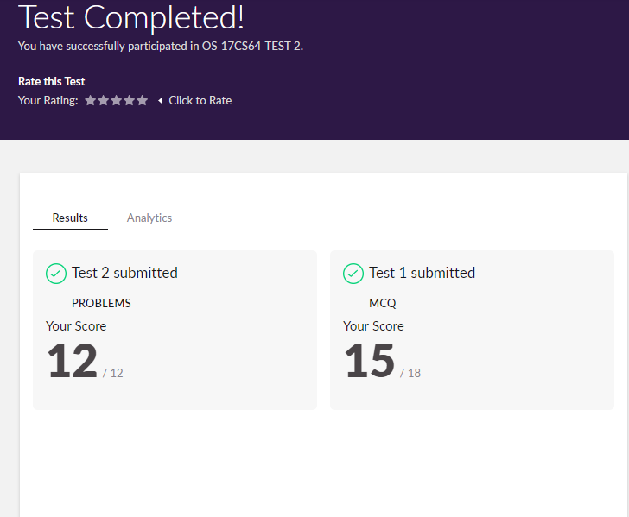

Certification Course Details:

Report

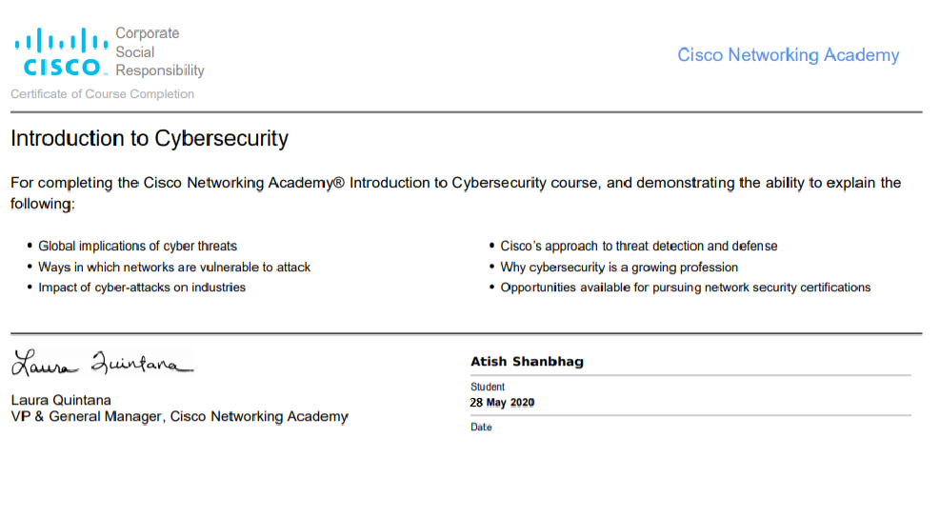

In today’s session of online certification I have successfully completed the course of Introduction to cybersecurity where it mainly focused of impact of cybersecurity in our global implications and also the how the impact of cybersecurity in industries.

Coding Challenges Details:

The below GitHub link for details

<https://github.com/atish-shanbhag/Updates>

P-1

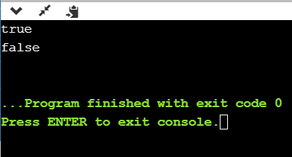

This program checks for equal no of brackets is open and closed if so it prints true or else return false.

P-2

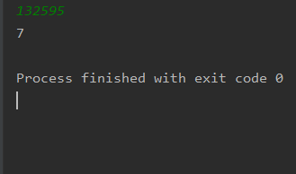

**This python program is to get digitroot of the number where we give a random number and until it become complete single digit it goes on calculate.**

**P-3**

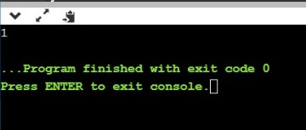

**This c program prints last remaining element in array.**

**P-4.1**

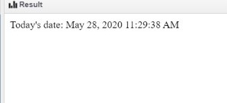

**JSP program to print current date and time.**

**P-4.2**

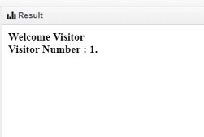

**Jsp program to print number of visitor visited the site.**